Edgemont, Various Stages – City of Edmonton
Project Information
Client Engineer Contract Value
Rohit Developments WSP $6.5 million
Project Length Project Type
2018 – present Residential

Specifications

- Pipe diameters up to 1200mm  - Pipe installed up to 9 meters deep | - ~300 Lots  - Ground moisture mitigation by use of joint restraints, washed rock, and cement stabilized backfill

Project Description

Eng-Con Holdings is the underground utilities contractor for the Edgemont Stage 9 and 3 subdivisions located in southwest Edmonton. The project consists of residential lot servicing, stormwater management facility construction and the installation of some very deep sewer mains.
The pipe sizes we installed ranged from small diameter 100mm service pipes up to large diameter 1200mm storm trunk sewer lines. These pipes were successfully installed up to 9m deep in some extremely challenging ground conditions.
The City of Edmonton’s ESC program, through WSP, was implemented and effectively followed throughout construction from CCC and is currently on-going.
Due to the extremely poor ground conditions and the very aggressive construction schedule imposed by the Client, it was imperative that Eng-Con collaborate with several different contractors on the site. The project also included the successful unique installation of a waterline with significant horizontal and vertical changes in grade via directional drilling under an environmentally sensitive creek bed. Tackling these significant challenges with the attitude that the Client, Engineer and Contractors are all on the same “team” and are striving for the same end goal, the project was completed on time and budget.

Project References

Consultant Client
Hemant Patel, Senior Contract Administrator Leanne Ure, Project Manager
(780) 224-3289 (780) 436-9015
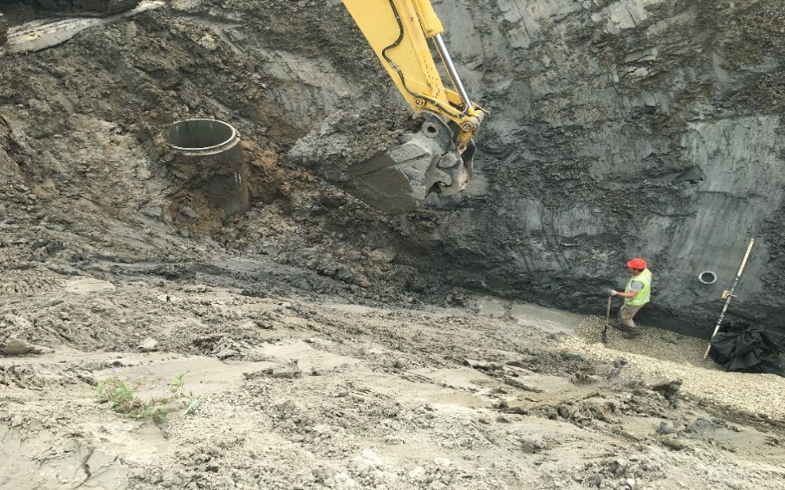
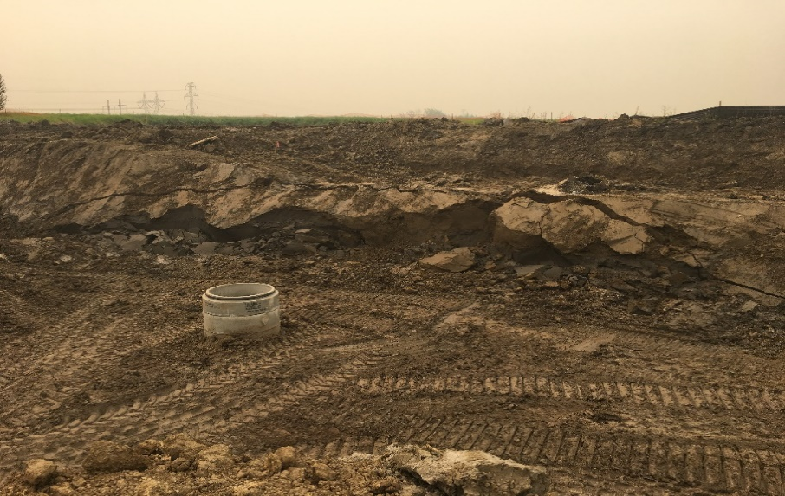
Hemant.patel@wsp.com Leanne.ure@rohitgroup.com

